EQUIVALENT TO UNICELL

Height | 800 1000mm | 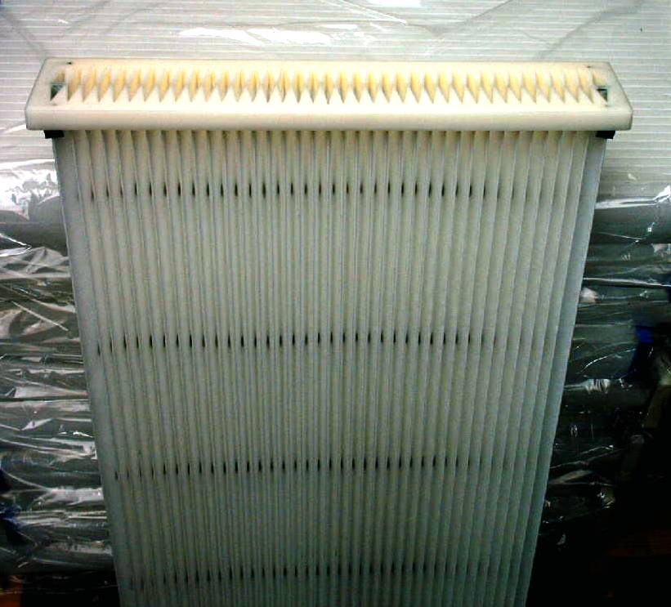
Equivalent to DCE  Our Ref | 6339 9000 6439 9000  DRCELL800P 1000P
Flange | 500 x 95mm
Bottom | 480 x 75mm
Gasket | None
Pleat number | 2 x 38
Pleat depth | 35mm
Filtration area | 4m2 5m2
Pleat spacing | Uniform pleat spacing on both inside and outside diameters for maximum life with minimum airflow restriction.
Filter media | A 240g/m2 Polyester.  0.62mm thickness  105-150 l/m2/sec Air Permeability
Inner sleeve | None
Outer sleeve | None
End caps | PU
Pleat/end cap bonding

Filter class | F9
Operating temperature | 120ºC

